The smart energy aggregator SEAS system

Background to the development of the SEAS system

The SEAS system was developed to accommodate a seamless integration of different subsystems that automate and control “everything” in a building with dynamic adaptation to the external connected systems (power plant, power grids, internet cloud services, load management etc) via a series of control mechanisms. The SEAS system has been in continuous build for 25 years and has evolved from a embedded hardware and software unit, the “Melacs” (during the years 1998-2024).

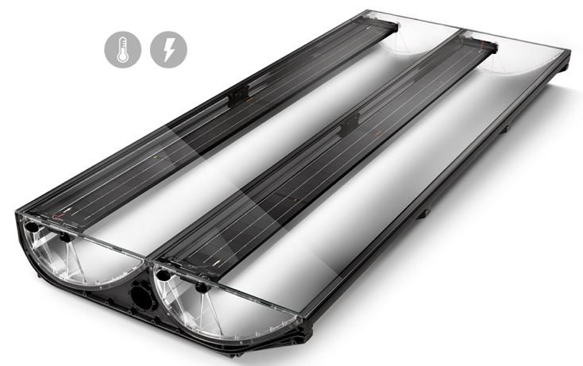

The SEAS with its internal embedded Melacs controller boards and PLC functionality was used in different advanced hybrid CPVT solar power plants that produce combined heat and power, that was designed by Maston group.

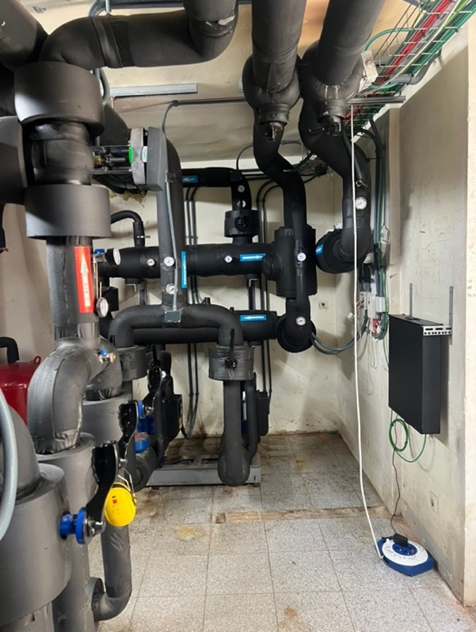
SEAS Ai Server Datalogger Meter

It has been using standard C-programming editor tools common in embedded systems, and was later implementing standard industry PLC control programming with structured text programming, ladder structure or pre-made symbols “tool-box” functions, pre-defined control models, general predictive control models, neural networks, novel adaptive self-learning models and others).

All critical functions in the SEAS system are generally coded in low level structured state machine code with thorough execution control to avoid computing crashes and data losses by utilizing distributed applications server technology (dApp) via blockhain based distributed servers running in Docker sandboxes etc, that may be connected with cloud IoT services as Thingsboard and similar.

And in recent years and within the Hystore project the SEAS system is expanded with an wider integration of software services and communication capabilities, that are combined with increased processor power to accommodate an extended IoT and Ai capacity.

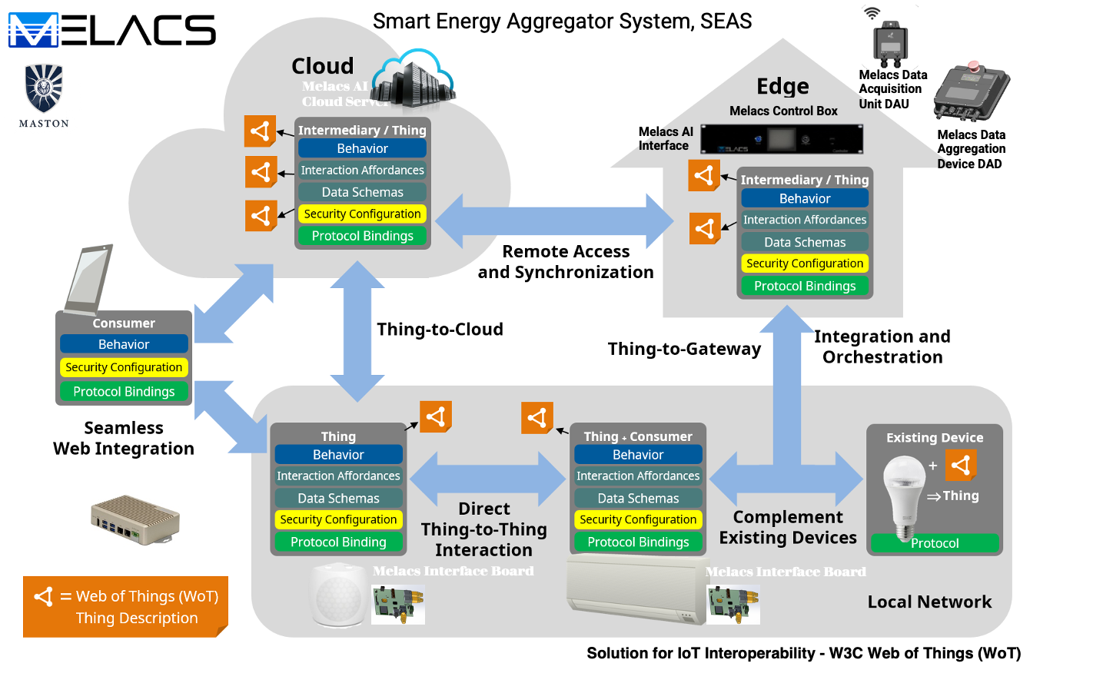

Hardware package in the SEAS system
The SEAS system is developed further in the Hystore project to manage and integrate building energy systems with all controllers and service robots and other IoT-units, and to enable energy efficiency in heating/cooling, power generating systems, and engage in load balancing of all internal and external loads etc.

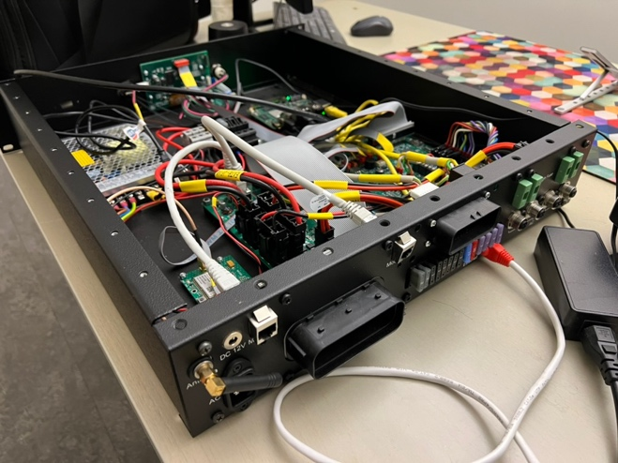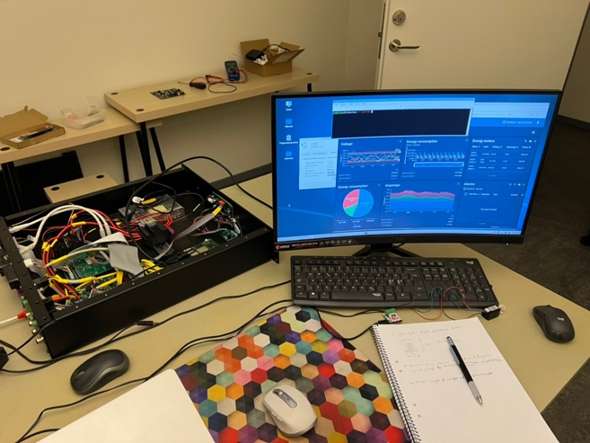

The main hardware system units are:
- Aggregator power plant server for Ai Cloud Datacenters. These are the centralized computing resources that can manage a local area or city of a higher number of SEAS Local Servers and Edge Servers.
- Aggregator local Server. For Ai/IoT systems in larger buildings of building complexes, running on-grid/off-grid control capability, it is a need to utilize several Edge Servers, and in this case a dedicated Aggregator Local Server may be used for sub-group management. This larger Local Server is designed to manage larger data storage and Ai-task management etc.
- Aggregator Edge Server unit. The edge units manage all local PCL and embedded controllers, sensors and other IoT gadgets in the building.
- Aggregator PLC units. This is the “Master” unit supervising all the local PLC’s and other controller in a system.
- Aggregator PLC Extension modules. The extension modules are continuously supervised by the Aggregator PLC unit to manage high speed tasks and general sensor reading, control of switches, relays, power modules, variable frequency drives, power supplies, inverters etc.
- External systems aggregator communication units. There are a growing number of aggregation communication and trading systems in development worldwide. The SEAS systems are designed to be able to integrate with such power and heating trading systems aggregator communication units, to allow collaboration and synchronization in real time between power/heating generation and the user load management controllers, or models.

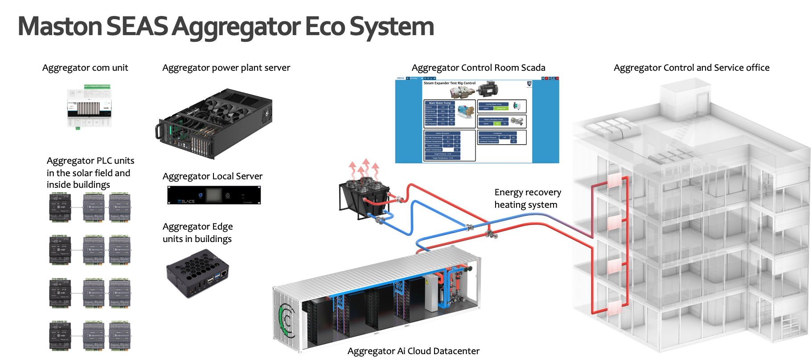

Aggregator PLC units
The i.MX 8M Mini is NXP’s first embedded multicore applications processor built using advanced 14LPC FinFET process technology, providing more speed and improved power efficiency. With commercial and industrial level qualification and backed by NXP’s product longevity program, the i.MX 8M Mini family may be used in any general purpose industrial and IoT application. The i.MX 8 applications processors are part of NXP's EdgeVerse™ edge computing platform.
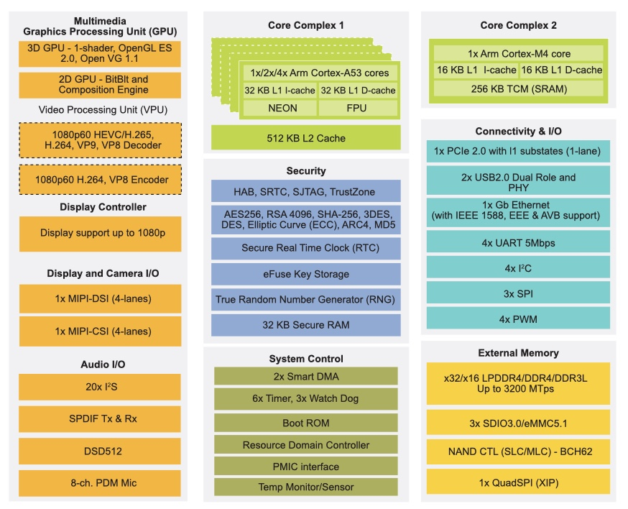

Aggregator Edge Server units
The i.MX 8M Plus family focuses on machine learning and vision, advanced multimedia, and industrial automation with high reliability. It is built to meet the needs of Smart Home, Building, City and Industry 4.0 applications.
- Powerful quad or dual Arm® Cortex®-A53 processor with a Neural Processing Unit (NPU) operating at up to 2.3 TOPS.
- Dual image signal processors (ISP) and two camera inputs for an effective advanced vision system.
- The multimedia capabilities include video encode (including h.265) and decode, 3D/2D graphic acceleration, and multiple audio and voice functionalities.
- Real-time control with Cortex-M7. Robust control networks supported by dual CAN FD and dual Gigabit Ethernet with Time Sensitive Networking (TSN).
- High industrial reliability with DRAM inline ECC.
i.MX 8 applications processors are part of NXP's EdgeVerseTM edge computing platform.

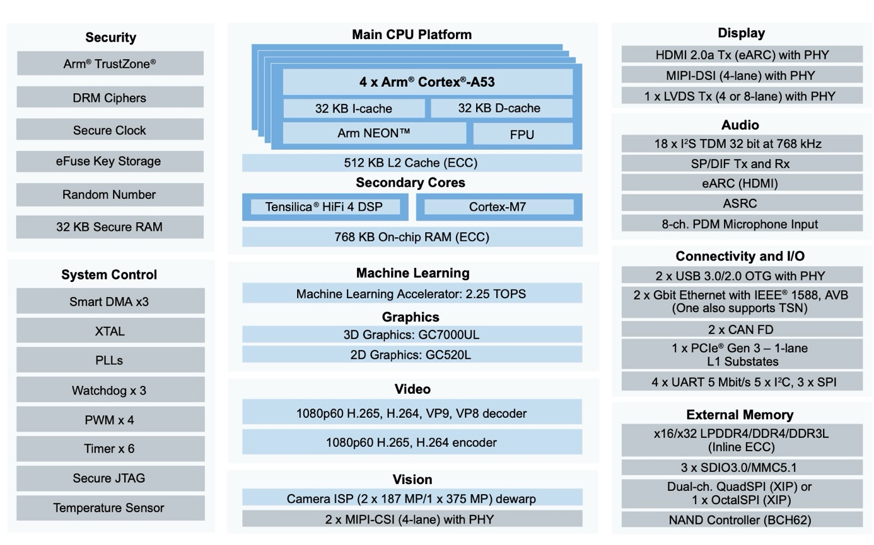

Aggregator Local Server

The Aggregator local server is built in a 19” rack module of 600mm depth and equipped with integrated UPS power supply, main boards with stacked ARM processor boards with CPU, GPU and NPU processors, and separate utility circuits boards with IO ports for connection to sensors and actuators etc. There are several possible processor boards that may be used in the Aggregator local server, but due to the need of low power consumption in Fallback mode, it is mainly ARM based circuits. This can be seen as a more powerful “PLC” unit that has capacity to operate more advanced tasks locally, and that manage Fallback operation when the external cloud is down.

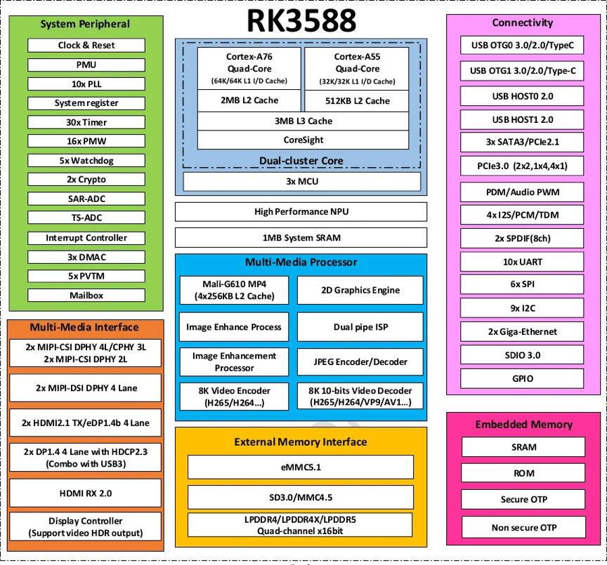

Aggregator power plant server for Ai Cloud Datacenters
The Aggregator power plant server for Ai Cloud Datacenters is designed to accommodate high capacity computing workloads and the SEAS OEM version that is in development in the Hystore project is built in a 19” rack enclosure with 600mm depth to allow easy installation in small racks, and equipped with a advanced set of processor CPU, GPU and NPU boards, with up to 50-500 processor cores operating in parallel, and with clustering of units in cloud service systems.

The Aggregator power plant server consumes more power than the smaller Aggregator units, and they are water cooled and the surplus heat can be utilized in the building heating system. This cooling/heating feature enables high total efficiency in the system level and may be used in district heating systems as well as local building HVAC systems.

Ai/IoT system limitations with current hardware and software
The system limitations in the SEAS system are caused by a rapid growing number of devices and services that are entering the market. A selection of such typical system technology limitations is presented below.

Internet of Things system limitations
The Internet of Things (IoT) has rapidly transformed various industries by enabling enhanced data collection, automation, and operations efficiency. However, despite its benefits, IoT systems come with several inherent limitations and challenges:

1. Security and Privacy
- Vulnerabilities: IoT devices often lack robust built-in security features, making them susceptible to cyberattacks. This can include everything from unauthorized data access to taking control of the devices.
- Privacy Concerns: IoT devices generate vast amounts of data, some of which can be highly sensitive. Ensuring the privacy and proper handling of this data is a significant challenge.

2. Scalability
- Network Management: As the number of connected devices grows exponentially, managing these devices and the data they produce becomes increasingly complex. Network congestion and the efficient routing of data can also become problematic.
- Resource Allocation: IoT devices often operate on limited computing power and battery life, making it challenging to scale operations without impacting performance.

3. Interoperability
- Standardization Issues: There is a lack of universal standards for interoperability among IoT devices. Different manufacturers often have proprietary protocols, which can hinder the seamless integration of devices across various platforms.
- Legacy Systems: Integrating IoT solutions with older, existing technologies can be difficult and costly, as these systems were not designed to communicate with newer IoT protocols.

4. Data Management and Analysis
- Data Overload: IoT devices can generate enormous volumes of data. Collecting, storing, processing, and analyzing this data in a meaningful way requires sophisticated and often expensive data management systems.
- Quality of Data: The usefulness of data collected can vary greatly. Inaccurate, incomplete, or irrelevant data can lead to poor decision-making and inefficiencies.

5. Reliability and Stability
- Device Failure: IoT devices are often deployed in large numbers in unmonitored or remote locations, where failures can go undetected and unaddressed for long periods.
- Network Reliability: IoT systems are heavily dependent on continuous network connectivity. Network failures can disrupt the entire operation, especially in systems designed to perform critical real-time functions.

6. Power Consumption
- Energy Requirements: Many IoT devices are battery-powered and need to operate for extended periods without maintenance. Designing devices that consume low power while maintaining performance is a continuous challenge.
- Sustainability: The environmental impact of producing, deploying, and disposing of millions of IoT devices is a growing concern.

7. Regulatory and Legal Issues
- Compliance: Adhering to regional and global regulations regarding data protection (like GDPR) can be complex, especially when IoT systems span multiple jurisdictions.
- Liability: Determining liability in cases of IoT failures or breaches can be complicated, especially when multiple parties (device manufacturers, software providers, service operators) are involved.
Addressing these limitations is crucial for the continued growth and effectiveness of IoT systems. Efforts from industry leaders, standardization bodies, and regulatory agencies are ongoing to resolve these issues, aiming to enhance the security, reliability, and usability of IoT technologies.

Programmable Logic Control (PLC) systems limitations
Industrial Programmable Logic Controllers (PLCs) are the backbone of modern automation systems. While highly effective, they also come with several inherent limitations, particularly as the demands of modern industrial environments evolve. Here are some of the main limitations found in today's PLCs:

1. Scalability
- Hardware Constraints: Traditional PLCs can be difficult to scale up due to their fixed number of I/O ports and limited processing capabilities. Expanding a system often requires additional modules or even entirely new PLCs, which can increase complexity and costs.
- Software Limitations: PLC programming environments and tools can be less flexible compared to more modern programming languages, making it challenging to implement complex algorithms or integrate with advanced data processing systems.

2. Integration with IT Systems
- Network Connectivity: Older PLCs often lack advanced networking capabilities, making it difficult to integrate them seamlessly into IT networks or the Internet of Things (IoT).
- Data Accessibility: Extracting data from PLCs for use in enterprise-level systems can be cumbersome, as many PLCs are not natively designed to communicate with other types of business intelligence or data analytics platforms.

3. Real-Time Data Processing
- Processing Power: PLCs generally have limited CPU capabilities, which can be a bottleneck when high-speed, real-time data processing is required, especially for complex algorithms like those used in AI and machine learning.
- Latency Issues: In high-speed manufacturing processes, even minimal delays in processing and response times can lead to inefficiencies and production issues.

4. Programming and Maintenance
- Specialized Skills: Programming PLCs typically requires knowledge of specialized, often proprietary, languages like Ladder Logic, Structured Text, or Function Block Diagram. This can limit the pool of available programmers and increase training costs.
- Maintenance and Updates: Updating PLC software or making significant changes to the system can be disruptive and often requires system downtime, which can be costly in continuous production environments.

5. Cost
- Initial Investment: High-quality PLCs are expensive due to their robust construction designed to withstand harsh industrial environments. The initial setup, programming, and installation also contribute to the high costs.
- Expansion Costs: Modifying or expanding a PLC-based system can be disproportionately expensive, as it often requires additional proprietary hardware and software.

6. Security
- Vulnerability to Cyber Attacks: As industrial systems become more connected, PLCs are increasingly targets for cyberattacks. Many older PLCs lack the advanced security features required to defend against modern threats.
- Ongoing Security Management: Ensuring that PLC systems are secure from threats requires continuous updates and monitoring, which can be difficult to manage, especially in systems that were not originally designed with connectivity in mind.
These limitations highlight the need for ongoing innovation in PLC technology and the integration strategies used in industrial automation. As industry requirements grow more complex and data-driven, the role of PLCs is also evolving to accommodate more advanced computing tasks, better integration capabilities, and enhanced security measures.

Communication in the SEAS system
Communication hardware and protocols are fundamental components of IoT and AI systems, especially in edge computing environments where efficient, reliable, and secure data transmission is crucial.

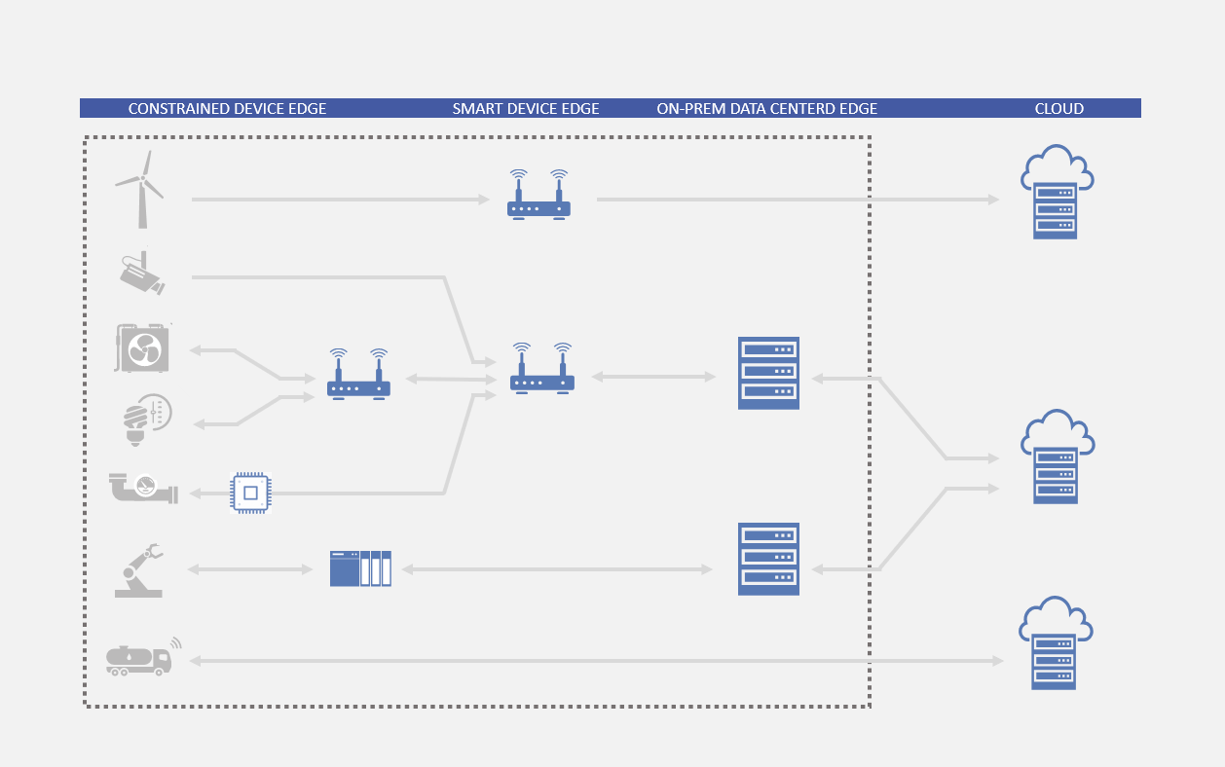
Here's a summary of the key elements:

Communication Hardware
- Network Interface Cards (NICs): These are essential for enabling devices to connect to a network, whether it's wired Ethernet or wireless.
- Gateways: Act as the bridge between different network protocols and manage the data traffic from sensors to the server and the cloud.
- Routers and Switches: Manage traffic within the network, ensuring data is sent and received by the correct devices.
- Modems: Convert data between digital formats used in computing devices and the analog signal used in telephone lines, often used for remote edge installations.
- Wireless Transmitters/Receivers: Devices like Zigbee, Z-Wave transmitters, Wi-Fi, and Bluetooth modules, crucial for remote or difficult-to-wire environments.

Communication Protocols

Networking Protocols
- HTTP/HTTPS: Commonly used for secure web-based access to devices.
- TCP/IP: The fundamental suite of protocols governing the internet, crucial for data transmission over networks.

IoT Protocols
- MQTT (Message Queuing Telemetry Transport): A lightweight messaging protocol designed for limited bandwidth and unreliable networks, which makes it ideal for many IoT scenarios.
- CoAP (Constrained Application Protocol): A web transfer protocol for use with constrained nodes and constrained networks in the Internet of Things, similar to HTTP but simpler and lighter, useful for simple electronic devices.
- AMQP (Advanced Message Queuing Protocol): Supports reliable and secure messaging, and is suitable for high-throughput enterprise environments.

Industrial Protocols
- Modbus: Widely used in industrial environments for connecting electronic devices.
- CAN bus (Controller Area Network): Common in automotive applications, connects multiple microcontrollers in environments without a host computer.
- RS485: RS-485 is often used to connect controllers, sensors, actuators, and other industrial equipment within a distributed network. Building Automation: Useful for managing HVAC, lighting, and access systems over long distances with minimal wiring. Remote Monitoring: Due to its robustness and long-distance capabilities (up to 1200m), RS-485 is ideal for applications requiring remote monitoring and control.

Wireless Protocols
- Wi-Fi: Ubiquitous for wireless networking within buildings.
- Bluetooth and BLE (Bluetooth Low Energy): Common for short-range communication, particularly in wearable and mobile devices.
- Zigbee/Z-Wave: Typically used for home automation, low-energy mesh networks.

Real-time Communications
- WebRTC (Web Real-Time Communication): Enables real-time communication directly in web browsers, useful for live video streaming or peer-to-peer sharing among IoT devices.

Specialized AI and Data Protocols
- gRPC: A high-performance RPC (remote procedure call) framework that uses HTTP/2 as its transport layer, very efficient for connecting services in microservices-style architectures, often used in AI applications for efficient server-client interactions.

Summary of protocols
Edge servers for IoT and AI typically utilize a mix of these hardware components and protocols to manage and facilitate communication across various devices and systems. The choice of protocols and hardware depends on factors such as the specific application requirements, the environment, the scale of the deployment, and the need for real-time processing and responsiveness. The right combination ensures the edge computing system is robust, efficient, and scalable, capable of handling the demands of modern IoT and AI tasks.
In the SEAS system it was a wider task to enable automatic identification and integration of the edge server system to all subsystems controller and IoT-units within the building or a local area of buildings.

Software package
Background description of typical software’s and subroutines generally used in IoT systems, and the selected packages for the SEAS system.
Setting up an edge server to continue providing services when the internet connection is lost involves implementing a range of strategies to ensure resilience and local functionality. Here are some key components and strategies that are used:
- Local Data Storage: An essential part of making an edge server function independently of the internet is to have local storage of critical data and applications. This ensures that the server can continue to operate using locally available resources without needing to access a central server or cloud services. The SEAS use a SQL database and can accommodate others if wanted, running in the PLC’s and servers of the system. All connected devices data are also stored if wanted by the user. The SEAS system also has a redundancy mechanism of the data storage.
- Caching: Implement caching mechanisms to store frequently accessed data and content. This allows the edge server to serve requests from cache even when it cannot fetch data from the internet. The SEAS utilize embedded memory circuitry and connected NVMI drives to store data.
- Fallback Mechanisms: Designing the system with fallback procedures to handle scenarios where the internet is unavailable is crucial. This might include switching to local databases or enabling certain restricted modes of operation that do not require internet access. The SEAS utilize its own structure to enable the Fallback Mechanism (FM).
- Decentralized Architecture: Deploy services in a way that they do not solely rely on a central point. This can be achieved by distributing functionalities across multiple edge servers or using a mesh network where nodes communicate directly with each other.
- Network Redundancy: Although this does not help if the entire internet goes down, having multiple network connections (like cellular data alongside traditional broadband) can protect against the failure of a single service provider.
- Battery Backup/UPS: Ensuring that the server has an uninterrupted power supply (UPS) can help maintain services during power outages, which often coincide with internet outages, particularly in disaster scenarios.
- Regular Updates and Maintenance: Keep the edge server’s software and data regularly updated during available connection times to reduce dependencies on real-time internet access for updates. Updates are made via a remote management tool (SEAS OTA).
- Autonomous Operations: Implement algorithms and operations that can function autonomously. For instance, IoT devices managed by the edge server should be able to operate using pre-set rules and data analytics models that do not require real-time internet connectivity. Besides earlier sub-systems for autonomous operation theer is new toolsets and functions being developed in Hystore.
- Security Measures: With increased autonomy and local data storage, security becomes even more critical. Implement robust security measures to protect the server and its data against unauthorized access, especially since it might not be able to rely on real-time security updates and patches. The SEAS system has both hardware and software security in the development.
Implementing these strategies in the SEAS requires careful planning and testing to ensure that the edge server can handle disconnections gracefully while maintaining as much functionality as possible.
The subroutines and software services needed on a SEAS edge server largely depend on its specific use case, the operational environment, and the kind of devices it interacts with. However, there are several common types of software and services that are typically employed to enhance functionality, manage tasks, and ensure security on edge servers. Here’s a breakdown of essential software categories and example functionalities:

Core Services
- Operating System (SEAS OS): A lightweight, secure real-time OS, depending on the application requirements (it is based on Debian Linux core).
- Containerization: Tools like Docker or Kubernetes for container orchestration can help in deploying and managing lightweight, isolated service units.
- Data Management: The SEAS database that can operate locally (e.g., SQLite, Redis and others) for storing and retrieving data efficiently.

Connectivity and Network Management
- Network Security: Firewalls, VPNs, and intrusion detection/prevention systems (IDS/IPS) to secure data flow.
- Communication Protocols: MQTT, CoAP, AMQP for IoT communications; HTTP/HTTPS for general web services; and specialized protocols like Zigbee or Z-Wave for home automation.
- Load Balancing: SEAS utilize software to distribute network or application traffic across multiple servers or processors to enhance responsiveness and availability. This functionality is further developed in the Hystore project to accommodate higher workloads.

Data Processing
- Stream Processing: Tools like Apache Kafka, RabbitMQ for handling real-time data streams.
- Data Caching: Implementing caching mechanisms using software like Memcached or Redis to enhance data retrieval speed and reduce latency.
- Analytics and Machine Learning: Edge-based analytics software, TensorFlow Lite for machine learning models that can run locally for predictions without needing cloud processing.

Application-Specific Services
- Device Management: Software to manage and monitor the status, configuration, and operation of connected IoT devices.
- Sensor Data Handling: Subroutines for processing and reacting to sensor data inputs, possibly including data normalization, aggregation, and time-series analysis.
- Automated Decision Making: Rules engines or scripts that allow devices to make autonomous decisions based on sensor inputs and predefined logic.

Utility Services
- Logging and Monitoring: Tools for logging system and application events locally and, conditions permitting, syncing them to a central log management service. Popular tools include ELK Stack or Splunk.
- Backup and Recovery: Software to periodically back up configurations and data locally and, if possible, to the cloud.
- Update Management: Mechanisms to handle and apply software and security updates locally to ensure the system remains secure and functional with minimal downtime.

Security Features
- Encryption: Implementing encryption at rest and in transit to protect sensitive data.
- Authentication and Authorization: Services for managing user and device authentication and authorization, such as OAuth, JWT, or LDAP.
- Regular Security Assessments: Automated tools for scanning vulnerabilities and ensuring compliance with security standards.
Choosing and implementing these subroutines and services requires an understanding of the specific requirements of the edge environment and the tasks the edge server needs to perform. Moreover, the architectural design should focus on modularity and scalability to accommodate future enhancements and integrations. The SEAS is managing all aggregator server hardware systems and software subsystems necessary for the system redundancy, and they are adapted to run the open source Thingsboard platform applications on top of the backend server functionality, with all embedded PLC control services and IoT-services etc, routed through the SEAS system that acts as a “virtual internet” when it goes into Fallback Mechanism operation. The Thingsboard platform enables visualization of data in dashboards, and forward all API’s and DataStream’s and HMI/Scada screens etc.

